Project Design Phase-II
Technology Stack (Architecture & Stack)
Date | 07 July 2026
Team ID | SWTID-2026-2247
Project Name | Emotion Detection and Learning Support Engine
Maximum Marks | 4 Marks

Technical Architecture:
Following the reference pattern's USER / CLOUD / ADMIN swimlane style, the diagram below shows the Student on the left initiating input (webcam, mic, or chat), the Cloud in the center performing emotion detection, sentiment analysis, and generating adaptive learning recommendations, and the Teacher/Admin on the right receiving dashboard updates and real-time alerts.
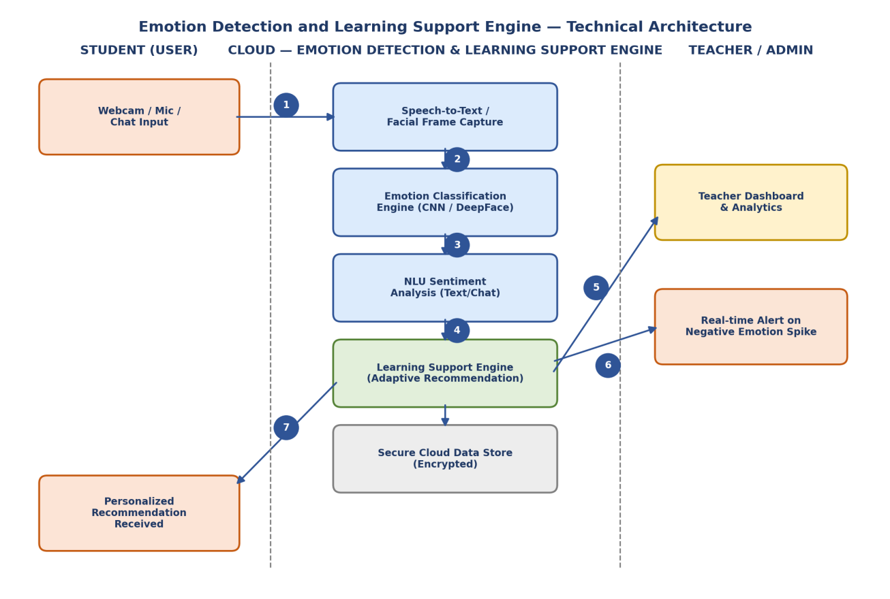

Table-1: Components & Technologies:
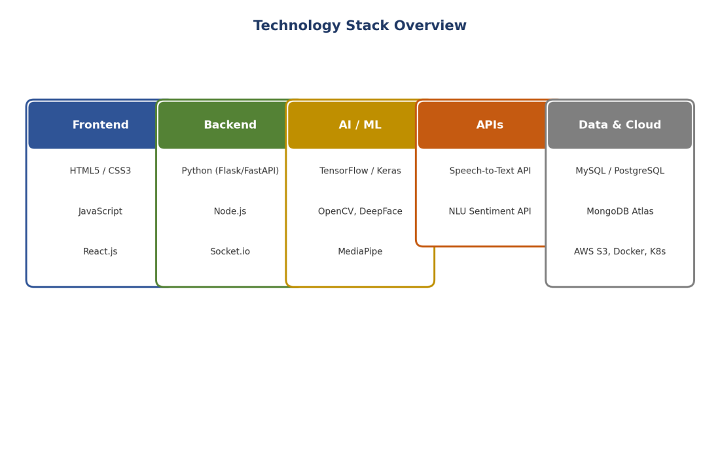
S.No | Component | Description | Technology
1. | User Interface | Web dashboard and mobile-friendly UI through which students, teachers, and parents interact with the system (login, mood check-ins, dashboards, alerts). | HTML5, CSS3, JavaScript, React.js
2. | Application Logic-1 | Core logic for capturing and classifying student emotions from webcam video, audio, and text inputs in real time. | Python, TensorFlow/Keras, OpenCV, DeepFace
3. | Application Logic-2 | Logic for generating personalized learning content and adjusting difficulty based on the detected emotional state. | Python, Flask / FastAPI, scikit-learn
4. | Application Logic-3 | Logic for real-time alerts and notifications to teachers/parents when negative emotion patterns are detected. | Node.js, Socket.io, Firebase Cloud Messaging
5. | Database | Stores student profiles, learning history, course content, and session metadata. | MySQL / PostgreSQL
6. | Cloud Database | Stores emotion logs, analytics data, and usage trends at scale on the cloud. | MongoDB Atlas / IBM Cloudant / Firebase Firestore
7. | File Storage | Temporary storage of video/audio frames for processing and generated reports. | AWS S3 / Azure Blob Storage
8. | External API-1 | Converts spoken input to text for voice-tone and speech-based emotion analysis. | Google Cloud Speech-to-Text / IBM Watson STT
9. | External API-2 | Performs sentiment/NLU analysis on student chat and quiz-response text. | IBM Watson NLU / OpenAI API
10. | Machine Learning Model | Facial emotion recognition model trained to classify emotions such as confusion, stress, boredom, and engagement. | CNN (FER-2013 based), DeepFace, MediaPipe Face Mesh
11. | Infrastructure (Server / Cloud) | Local: Dockerized services on a local development server.  Cloud: Containerized microservices with auto-scaling. | Docker, Kubernetes, AWS EC2 / Azure App Service

Table-2: Application Characteristics:
S.No | Characteristics | Description | Technology
1. | Open-Source Frameworks | Open-source frameworks used for UI, backend, and AI processing across the application. | TensorFlow, OpenCV, React.js, Flask, scikit-learn
2. | Security Implementations | Encryption of stored emotion/biometric data, secure authentication, and access control to protect sensitive student data. | AES-256 encryption, HTTPS/TLS, OAuth 2.0, RBAC, OWASP guidelines
3. | Scalable Architecture | Microservices-based architecture allows each engine (detection, recommendation, alerts) to scale independently based on load. | Docker, Kubernetes, Microservices
4. | Availability | Load balancing and multi-zone deployment ensure the platform remains available during peak classroom usage. | AWS ELB / NGINX, Multi-AZ deployment, Auto-failover

S.No | Characteristics | Description | Technology
5. | Performance | Caching of frequent queries and CDN delivery of static assets ensure fast response for real-time emotion detection. | Redis Cache, CloudFront / Azure CDN

C4 Model Architecture Views (per c4model.com):
As recommended by the C4 model referenced below, the following two views describe the system at increasing levels of detail: a System Context diagram (system boundary and external actors/services) and a Container diagram (deployable units and the AWS cloud infrastructure they run on, in line with the AWS Architecture Center reference).

Level 1 — System Context Diagram
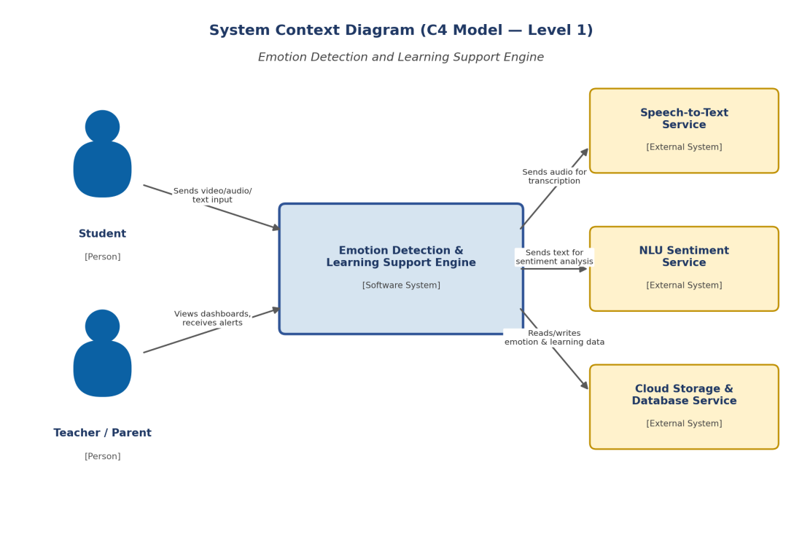

Level 2 — Container Diagram (AWS Cloud)
